Grade 1
Let’s Grow Our Knowledge of Plant and Animal Needs

Science, Art, Math & ELA

Cathryn Story

Table of Contents
Pg. 3 Visual Map of Learning
Pg. 4- 10 Outcomes
Pg. 11Books for my Classroom Library
Pg. 12-13 Appendix of Resources
Pg. 14 Timetable
Pg. 15- 20 Rational
Pg. 21- 24 KSA’s Addressed
Pg. 25- 26 Week’s Calendar of Activities
Pg. 27- 40 Daily Outlines
- Lesson plan will be sent in a separate email

Visual Map of Learning
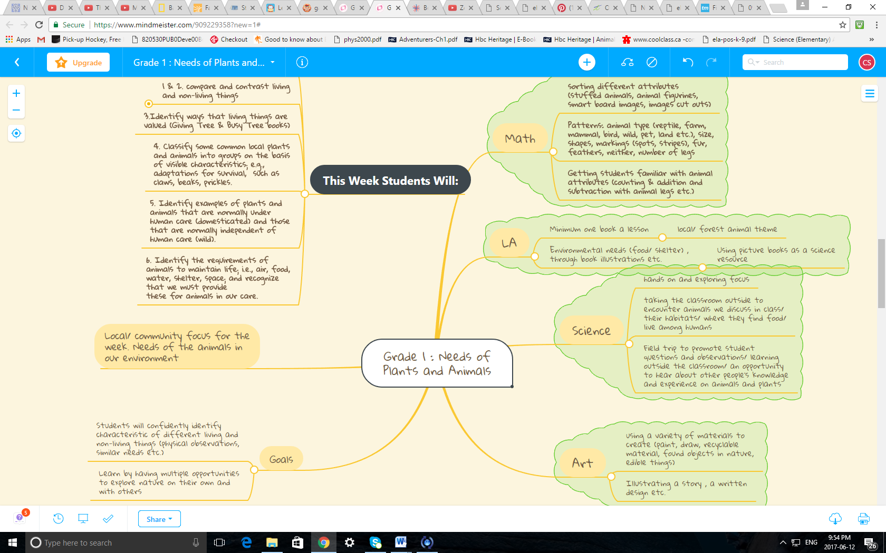
(My mind map image can be rotated and enlarged to read)
Outcomes
Science: Topic E: Needs of Animals and Plants
GLO: Students will describe some common living things, and identify needs of those living things.
SLO:
- Observe, describe and compare living things.
- Contrast living and nonliving things.
- Identify ways in which living things are valued; e.g., as part of a community of living things; as sources of food, clothing or shelter.
- Classify some common local plants and animals into groups on the basis of visible characteristics; e.g., adaptations for survival, such as claws, beaks, prickles.
- Identify examples of plants and animals that are normally under human care (domesticated) and those that are normally independent of human care (wild).
- Identify the requirements of animals to maintain life; i.e., air, food, water, shelter, space; and recognize that we must provide these for animals in our care
10. Give examples of ways in which animals depend on plants and ways in which plants depend on animals; e.g., particular plants may serve as a source of food and shelter, animals may help spread pollen and seeds.
Math
GLO: Develop number sense
SLO: 4. Represent and describe numbers to 20, concretely, pictorially and symbolically. [C, CN, V]
6. Estimate quantities to 20 by using referents. [C, CN, ME, PS, R, V]
9. Demonstrate an understanding of addition of numbers with answers to 20 and their corresponding subtraction facts, concretely, pictorially and symbolically, by:
- modelling addition and subtraction, using a variety of concrete and visual representations, and recording the process symbolically
10. Describe and use mental mathematics strategies (memorization not intended), such as:
- making 10
- using doubles [C, CN, ME, PS, R, V]
GLO: Use patterns to describe the world and to solve problems.
SLO: 3. Sort objects, using one attribute, and explain the sorting rule.
[C, CN, R, V]
GLO: Use direct and indirect measurement to solve problems.
SLO: 1. Demonstrate an understanding of measurement as a process of comparing by:
• identifying attributes that can be compared
• ordering objects
• making statements of comparison
• filling, covering or matching. [C, CN, PS, R, V]
GLO: Describe the characteristics of 3-D objects and 2-D shapes, and analyze the relationships among them.
SLO: 2. Sort 3-D objects an
ELA:
GLO: 1. Students will listen, speak, read, write, view and represent to explore thoughts, ideas, feelings and experiences.
SLO: Discover and Explore

-experiment with different ways of exploring and developing stories, ideas and experiences
- talk with others about something recently learned
- make observations about activities, experiences with oral, print and other media texts
- share personal experiences that are clearly related to oral,

  - Clarify and Extend
- listen and respond appropriately to experiences and feelings shared by others
- group ideas and information into categories determined by an adult
- ask questions to get additional ideas and information on topics of interest
GLO: 2. Students will listen, speak, read, write, view and represent to comprehend and respond personally and critically to oral, print and other media texts.
SLO: Use Strategies and Cues
2.1
- use a variety of strategies, such as making predictions, rereading and reading on
- talk about print or other media texts previously read or viewed
- identify the main idea or topic of simple narrative and expository texts
- preview book cover, pictures and location of text to assist with constructing and confirming meaning
- use personal word books, print texts and environmental print to assist with writing
SLO: Respond to Texts

- illustrate and enact stories, rhymes and songs
- relate aspects of stories and characters to personal feelings and experiences
- retell interesting or important aspects of oral, print and other media texts
SLO: Understand Forms, Elements and Techniques

- tell what characters do or what happens to them in a variety of oral, print and other media texts
- demonstrate interest in repetition, rhyme and rhythm in shared language experiences, such as action songs and word play
SLO: Create Original Text
2.4
- write, represent and tell brief narratives about own ideas and experiences
GLO: 3. Students will listen, speak, read, write, view and represent to manage ideas and information.
SLO: Plan and Focus
3.1
- connect information from oral, print and other media texts to topics of study
- ask and answer questions to satisfy information needs on a specific topic
- follow spoken directions for gathering ideas and information
SLO: Select and Process
3.2
- find information on a topic, using a variety of sources, such as picture books, concept books, people and field trips
- use text features, such as illustrations, titles and opening shots in video programs, to access information
SLO: Organize, Record and Evaluate
3.3
- Identify or categorize information according to sequence, or similarities and differences
- list related ideas and information on a topic, and make statements to accompany pictures
SLO: Share and Review
3.4
- Answer questions directly related to texts
- Talk about information- gathering experiences by describing what was interesting, valuable or helpful
GLO:4. Students will listen, speak, read, write, view and represent to enhance the clarity and artistry of communication.
SLO: Enhance and Improve
4.1
- ask or respond to questions or comments related to the content of own or others’ pictures, stories or talk
- check for obvious spelling errors and missing words
- print letters legibly from left to right, using lines on a page as a guide
- use appropriate spacing between letters in words and between words in sentences
- experiment with letters, sounds, words and word patterns to learn new words
- use words and pictures to add sensory detail in oral, print and other media texts
SLO: Attend to Conventions
4.2
- write simple statements, demonstrating awareness of capital letters and periods
- speak in complete statements, as appropriate
-use phonic knowledge and skills and visual memory to attempt spelling of words needed for writing
- know that words have conventionally accepted spellings
SLO: Present and Share
4.3
- present ideas and information to a familiar audience, and respond to questions
- add such details as labels, captions and pictures to oral, print and other media texts
be attentive and show interest during listening or viewing activities (What’s alive noises)
GLO: 5. Students will listen, speak, read, write, view and represent to respect, support and collaborate with others.
SLO: Respect Others and Strengthen Community
5.1
- work in partnerships and groups
- help others and ask others for help
Art
GLO: AN INDIVIDUAL EXPERIENCE
GLO: A CREATIVE EXPERIENCE
GLO: AN ENVIROMENTAL EXPERIENCE
SLO: Reflection
1. Students will notice commonalities within classes of natural objects or forms.
B. Natural forms are related to the environment from which they originate.
C. Natural forms have different surface qualities in colour, texture and tone
2. Students will assess the use or function of an object:
- Designed objects serve specific purposes.
3. Students will interpret artworks literally.
- Art takes different forms depending on the materials and techniques used.
C. An artwork tells something about its subject matter and the artist who made it.
SLO: DEPICTION:
1. Students will learn the shapes of things as well as develop decorative styles.
D. Animals and plants can be represented in terms of their proportions.
2. Students will increase the range of actions and viewpoints depicted.
A. Movement of figures and objects can be shown in different ways.
Students will represent surface qualities of objects and forms.
- Texture is a surface quality that can be captured by rubbings or markings
F. Details enrich forms
SLO: COMPOSITION
3. Students will add finishing touches.
A. Finishing touches (accents, contrasts, outlines) can be added to make a work more powerful.
B. Stepping back from a work helps in judging how it can be improved.
SLO: EXPRESSION
- Students will record or document activities, people and discoveries.
- Special events, such as field trips, visits and festive occasions can be recorded visually.
D. Knowledge gained from study or experimentation can be recorded visually.
6. Students will develop themes, with an emphasis on personal concerns, based on
A. Plants and animals
7. Students will use media and techniques, with an emphasis on exploration and direct methods in drawing, painting, print making, sculpture, fabric arts, photography and technographic arts.
• Use drawing tools to make a variety of lines—curved, straight, thick, thin, broken, continuous
• Make drawings from direct observation

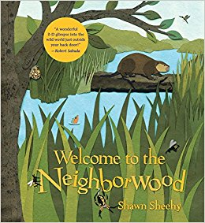
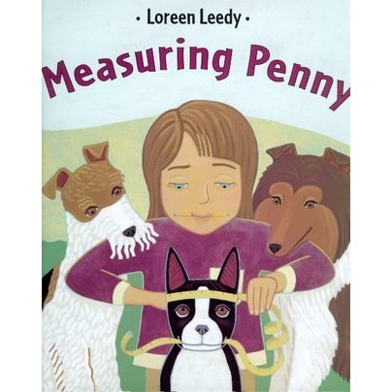
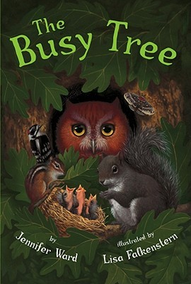
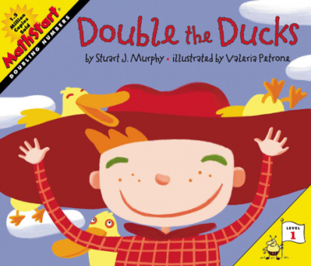
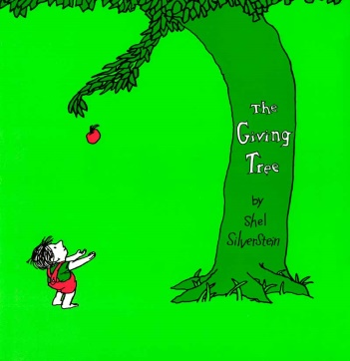
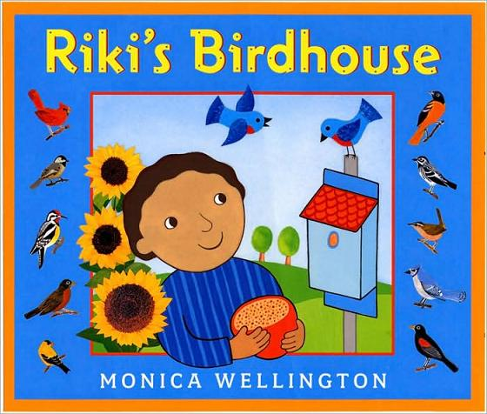
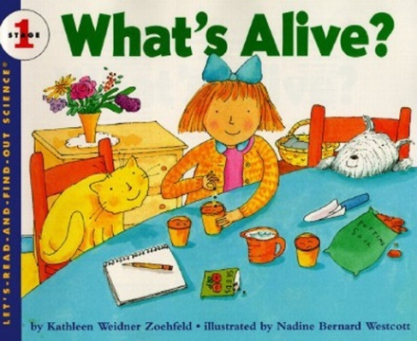

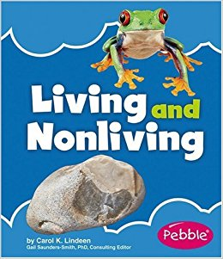
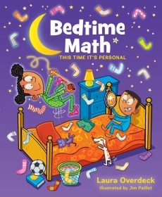
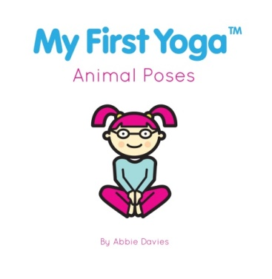

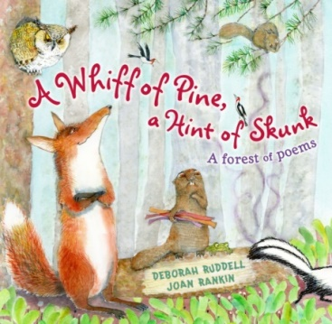
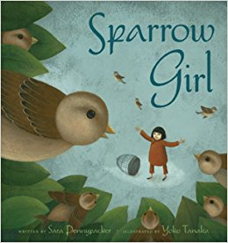
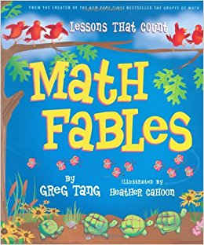
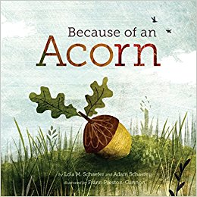

Appendix of Resources
Websites for Students Finished Work Early/ During Computer Time:
https://www.funbrain.com/games/whats-the-word (Individual free time)
http://www.abcya.com/counting_fish.htm (Individual free time)
http://pbskids.org/splashandbubbles/games/help-our-kelp (Sorting game with facts about ocean life- expands on our Monday’s math lesson)
http://www.storylineonline.net/stellaluna/ (Literacy help: where students can listen and read along to a variety of books)
http://www.switcheroozoo.com/games/pleasedofeedtheanimals.htm ( For a brain break as a class)
http://www.nwf.org/Garden-For-Wildlife/Create/At-Home/Kids-Garden-for-Wildlife.aspx
(For students to explore on at home or school)
Tuesday’s Science Class Review Video:
https://www.youtube.com/watch?v=BEz7RPvQCAI
Website for our Wednesday’s Math Class:
http://kids.nationalgeographic.com/animals/ (animal sizes for math)
Animal Needs Song/ Video (used throughout the week):
https://www.youtube.com/watch?v=k4UDf3tF_O4&app=desktop
Lesson Plan Resources:
http://choices4children.blogspot.ca/2013/10/move-like-animal-cube.html?m=1
http://ilove2teach.blogspot.ca/2011/10/create-animal-create-plant-freebie.html
https://www.education.com/worksheet/article/owl-color-by-number/
Yoga pose book is included in my collection of book I plan to use for the week.
Field Trip Outcomes and Booking Information:
http://www.lethbridge.ca/Things-To-Do/Nature-Centre/Pages/Book-A-Tour.aspx

Activities for LA: (to accompany a picture book and our field trip)
50 Literacy Stratagies by Gail E. Tompkins p. 56 ‘Interactive Writing’ and p. 103 ‘Quilts’

Timeline/ Week Calendar

Time | Monday | Tuesday | Wednesday | Thursday | Friday
8:40-9:10 | LA | LA | LA | Leave for Helen Shuler | LA
9:10-9:40 | LA | LA | LA | Helen Shuler | Art
9:40-10:10 | LA | LA | LA | Helen Shuler | Art
10:10-10:15 | Snack Time | Snack Time | Snack Time | Snack Time | Snack Time
10:15-10:27 | Recess | Recess | Recess | Recess | Recess
10:30-11:00 | Science | Science | Science | Helen Shuler | Math
11:00-11:30 | Science | Science | Science | Helen Shuler | Science
11:30-12:00  11:30-12:05 Friday (Early Dismissal) |  |  |  | Return back to the school | Science
12:00-12:37 | Lunch | Lunch | Lunch | Lunch | xxxxxxxxxxx
12:40-1:10 | Math | Math | Math | LA | xxxxxxxxxxxx
1:10-1:40 | Math | Math | Math | Science | xxxxxxxxxxxx
1:40-2:07 | D.E.A.R/ Computers | D.E.A.R/ Computers | D.E.A.R/ Computers | Science | xxxxxxxxxxxx
2:07-2:22 | Recess | Recess | Recess | Recess | xxxxxxxxxxxxx
2:22-2:55 | Art | Art | Art | Art | xxxxxxxxxxxx
2:55-3:25 | Art | Art | Art | Art | xxxxxxxxxxxx

Rationale
Section of Needs of Plants and Animals We Will Cover this Week
This week’s unit begins with an introduction to living and non-living things because Monday will be the first day that the needs of plants and animals will be introduced to students. Throughout the week students will be dancing, doing hands on learning, working independently , working collaboratively with the whole class, presenting their work to others and taking learning outside of the classroom.
Plant needs will not be the focus this week. I think the needs of plants would be addressed the following week and on the Monday and we could use a Venn diagram to look at the differences and similarities between needs of plants and animals. The Venn diagram activity could simultaneously be a review and a way to introduce new content related to the previous week’s animal focus. We will briefly touch on the topic of plants in relation to how animals use them for things like food and shelter and how they appear in the majority of the picture books we will read as a class this week. Even though this week we are focusing on animal needs, I chose to start with “The Giving Tree” because it gives us a chance to talk about how people are also animals. This book does a good job of showing a positive relationship between a plant and an animal, as well as the value of a tree to humans .I thought the Giving Tree would be a good LA introduction resource to lead into our ‘What’s Alive?’ science focus that day so students understand that both animals and plants are living.
Overarching Questions I Plan to Ask and Have Answered this Week are:
-How can we tell if something is alive?
-Why are plants important to people and animals?
-What things do all animals need to survive?
-How can we show respect to nature and animals? (Should be covered during our outside art class and our field trip)
What do I want my Students to learn?
-I want my students to learn about the responsibilities of taking care of animals (pets) and how animal needs cannot be neglected because they are necessary for life. The books Measuring Penny, What’s Alive? And Double the Ducks all provide opportunities for the teacher to discuss different examples of domesticated and wild animals and different ways that those animals have their needs met.
- I want my students to learn sorting, measurement and counting using different visual representation and animal characteristics/ attributes.
- I want student’s to learn how to distinguish living things from non-living things and identify how they came to their conclusion.
- I want my students to learn about the needs of animals, primarily animals in their community and how living things are valuable to both humans and animals (ex. trees).
Plans to Assess and Evaluate Student Learning:
- Have them answer self- assessment questions Wednesday (middle of the week) and Friday (end of the week after culminating activity). Maybe keep the questions the same so they can see their progress.
-Through observing their participation in the song/ dance about needs of animals.
-If they can provide information for the culminating activity and describe needs of an animal (either: visually, verbally or by writing about it).
- If students can distinguish living things from non-living things (gummy worm worksheet, observations during our scavenger hunt, class discussions after reading picture books).
- All of my assessments for the week are formative, except for our culminating activity. In my detailed lesson plan where I introduce the ‘Create an Animal’ activity, I also included the rubric that I would use on the Friday after students have had multiple class periods to work on it and receive feedback from their teacher.
Beginning with LA Every Morning
I believe it is important for ECE teachers to establish a dependable morning routine for their students. The morning routine should help eliminate some stress that grade one students may feel if they are struggling to feel comfortable being away from parents or if they come from a chaotic home where their family members have unpredictable schedules. Morning routines can also make the classroom environment more inviting to students that regularly arrive a few minutes late. Late students will come in knowing exactly what subject and kinds of activities we will be working on, making it easier for them to join in with the rest of the class without causing disruptions to other student’s learning. Our Thursday morning field trip that interrupts the morning routine should be an exciting change of environment for the students. The teacher would have provided students with many reminders and discussed the importance of leaving at a certain time in order to take in all the activities.

Day one Living and Non-Living Scavenger Hunt
This is a scaffolding activity for students to prepare themselves before taking learning outside of the classroom and potentially exploring more independently. Our art period activity where students do rubbings of living and non-living things should work as a science review lesson. Hopefully by our fieldtrip on Thursday, students should feel comfortable with exploring nature for different living and non-living things in our local environment and classifying things they find instead of things presented to them by their teacher.
Math Centres
Sorting animals using a variety of variables to represent them will help students with identify patterns, making up their own sorting rules and guessing other’s reasons for sorting. While students are sorting animals they can have hands on experience with classifying animals into groups based on visible characteristics.
Having students bring in their own stuffed animals from home to use for our math class should help with student engagement because students will first want to share them with others. After students have a few minutes to share, teacher will ask students to pay close attention to their attributes, their stuffed animals will represent real animals and students can think about the things their stuffed animals would need to live if it was real and not in their care. We can also use their stuffed animals to discuss how it represents a living thing, but that the toy is not living itself (scaffolding for the earthworm/ gummy worm comparing sheet that student will do the following day). Using food to learn with animal crackers is one station where the teacher will have students look at details and the shapes of the crackers. Students can group similar ones together, use them as a unit of measurement or sort them using different rules for categorization. Students could use any of our animal objects to form their own addition and subtraction equations (ex. add the number of legs 3 cats have to the number of legs 2 birds have by drawing out the animals or using animal figures to work out the problem/ show their work). These centres should benefit students because they are giving them an opportunity to take control of their own learning and be responsible for staying on task without direct/ consistent supervision from their teacher.
On-Going and Key Strategies and Activities
Starting each day (except our field trip day) off with a book will show students that there are endless books to refer to about the needs of plants and animals. For the culminating activity students can use any of the books in our classroom to help them think of ideas for their animal if they feel stuck. All the books from our lessons are picture books, so students at all reading levels can still get information and idea from them on their own, even if they just use the illustrations. Introducing a variety of books this week should hopefully not overwhelm student, but encourage students to go off and find answers for themselves first before asking someone else for help.
Our needs of animals song/ dance will be used multiple times each day to familiarize students with key information and get students up and moving when they need brain breaks. Most days have triple LA to give us time to appreciate our book’s illustrations and talk about how they connect to animal needs. I do not want my student to feel like they should ever rush through a book so that they can find meaning from the story because I want them to understand that meaning often comes from analyzing the author’s words and looking at how the artwork enhances or clarifies them.
Collection of Literature
Each morning LA period will begin with students gathering together to listen to the teacher read the picture book that will guide our activities that follow. The first two rows of books are the books that we will use during this week’s lessons and the last two rows are books that would be useful to have in the classroom for student reading time (D.E.A.R). The books in this collection either focus on animal needs or touch on how living things are valued for things like food and shelter for both animals and humans.
On pages 47 and 69 in Bedtime Math by Laura Overdeck, there are math questions that students who finish their work early can do. Page 47 discusses animal characteristics and has math problems that are represented by how many legs different animals have and page 69’s math problems are about feeding your pets. All students should be able to use this book as a resource because both pages have four different questions with four levels of difficulty, so this book should be a good activity with built in differentiation for students below grade level or exceptional learners.
For LA on Friday we return to “Welcome to the Neighborwood” book because our interactive writing activity was done as a group and now students can use the familiar book to make words from the book and sort words independently. “Welcome to the Neighbourwood” is also used twice because this book is a pop-up book with incredibly detailed illustrations that students will likely want to take a second look at. This book could have probably been used by itself for the unit because it incorporates different aspects of the needs of animals and how plants and animals can benefit one another.
D.E.A.R/ Computer Timetable Slot
I did not include gym in this week’s unit because each day students will be doing multiple activities that requires them to be out of their chairs, dancing or exploring outside and of course still having recess and lunch breaks. Possibly our D.E.A.R/ computer time periods could become a gym period if students have extra energy to burn on any of the days this week. The D.E.A.R/ computer periods are meant to be flexible periods so students can explore any of the websites listed in the ‘Appendix of Resources’ section. These websites are safe for student use, free, accessible to students at home or school and include integrated games that compliment a lot of our lessons we will be doing this week. In my detailed lesson plan, one brain break is a yoga activity so students could choose to practice animal pose yoga in a small group or as a class during this time (could help teacher discuss the idea of mindfulness in their classroom).
Assignment During Field Trip
Math bingo sheets will apply student knowledge of standard and non-standard units of measurement from Thursday’s lesson where we read Measuring Penny (a girl measures dogs using a variety of units of measurement) and measured an animal we found while researching online, as a class. These bingo sheets are an activity to further help students get comfortable using multiple forms of measurement before our culminating activity that includes a measurement question is introduced to students later that day. This assignment helps students practice math concepts we have already gone over this week and will replace our math period for Thursday so the teacher can give students time in the afternoon to talk about what we learned during the field trip and work on their ‘Create an Animal’ assignment.
Culminating Activities
Our Thursday morning field trip to Helen Shuler Nature Centre allows to students to continue learning hands on and outside the classroom, while having an opportunity to ask other knowledge people questions about our unit topic. Talking with a nature guide about the needs of plants and animals should help reinforce the notion that all the activities and learning that took place at school has a practical purpose in our community.
‘Create an Animal’ incorporates 4 integrated subjects (science, art, ELA and math) and is my class’s culminating activity for their week focusing primarily on animal needs and attributes. The assignment includes one math question (measurement) to assess student’s understanding of standard and non-standard units. The writing portion combines both ELA and science because students are asked to write about the needs of their animal and the visual representation aspect integrates art. ELA outcomes are also met on the Friday when students present their work and answer and ask questions about their work and the work of others.
With this assignment I tried to provide student with a lot of freedom to show their creativity and acknowledge that student in my class will have different strengths. By assessing students using 3 categories (writing, visual representation and oral explanations) I think I have included a variety of common ways students express their learning and can show their teacher that they have learned, while also addressing any struggles they may be having. Not explicitly marking on writing alone (for example) helps give marks to students in other areas that highlight their strengths and should hopefully not have a student receive a ‘needs improvement’ mark for the assignment as a whole.
How to communicate student learning to parents:
-Teacher could take a video recording of each student reading the story they wrote in response to The Busy Tree book, and send the video to parent
-Teacher could start a binder for each student at the beginning of the year and add different pieces of work they did from each unit to give parents a collection of the progression of their child’s work in the class
- Share student self- assessment questions (during a parent teacher meeting the student could discuss their responses to their parents)
- Take pictures of students during our field trip and email them to parents (helps parents who were unable to be a parent volunteer see what their child was doing)
- We could invite parents to view students ‘Create an Animal’ projects on our sharing day
By the end of the week our class bulletin board will include:
- Anchor chart of ways the tree helped the boy during our morning discussion after reading The Giving Tree
- Anchor chart with our Needs of Animals dance moves written/ drawn or pictures of students doing the dance (for students to refer to while we continually go over the song)
- Quilt squares about our field trip
- Student’s ‘Create an Animal’ sentences
- Interactive writing (class collaborative writing product)
- Finger print animals (individual art work)
- Collage of the living and non-living rubbings students made for art

KSA’S Addressed:
KSA 3: The purposes of the Guide to Education and programs of study for subject disciplines you teach. Know how to use these documents to inform and direct your planning, instruction and assessment of student progress.
-I will use formative assessments starting day one to provide student with multiple opportunities to receive teacher and peer feedback
- I have included a mixture of activities that are group, whole class and individual
- Picture books are consistently used for instructional purposes throughout the week
KSA: 5: All students can learn, albeit at different rates and in different ways. Know how (including when and how to engage others) to identify students’ different learning styles and ways students learn. They understand the need to respond to differences by creating multiple paths to learning for individuals and groups of students, including students with special learning needs.
- My ‘Create an Animal’ rubric is very inclusive of a variety of learner paces and styles
- Differentiation and acknowledgment of exceptional learners is included in many of my lessons
KSA 6: The purposes of short, medium and long term range planning. Know how to translate curriculum and desired outcomes into reasoned, meaningful and incrementally progressive learning opportunities for students. Vary their plans to accommodate individuals and groups of students.
- I broke up The Needs of Plants and Animals by mainly focusing on animals this week and I tried to organize my lessons into manageable outcomes for students and that means that the weeks to follow will build on their knowledge of animals and apply it to plant needs
-Many activities are hands on and encourage students to explore different concepts individually and with others
- An end of the week field trip was included to extend student knowledge of the unit and change student’s learning environments
KSA 7: Students’ needs for physical, social, cultural and psychological security. Know how to engage students in creating effective classroom routines. Know how and when to apply a variety of management strategies, in keeping with the situation and that provide for minimal disruptions to students’ learning.
-Our morning routine is something stable that all students can depend on. It would give the teacher a chance to check in with students and see how they are feeling that day and help make students feel welcome to participate and disclose personal information to their teacher. I would also allow my students to have a snack at this time, if they did not have breakfast yet.
- School related issues from a previous day could be discussed right at the start of the next school day , so that student have a chance to voice any concerns they wish to share with the teacher one on one or to the class as a whole.
- Classroom community building should take place during our morning meetings and various collaborative learning activities
-Reading and having carpet time each day should give students an opportunity to become settled, feel calm and prepare themselves for our learning activities by listening to a story.
KSA 8: Importance of respecting students’ human dignity. Know how to establish, with different students, professional relationships that are characterized by mutual respect, trust and harmony.
-I think that taking the class on a field trip is one way I can show my students that I trust them to behave politely and show respect to others.
- I give my students chances to be in charge of their learning with the math centres and the culminating activities
KSA 9: There are many approaches to teaching and learning. Know a broad range of instructional strategies appropriate to their area of specialization and the subject discipline taught, and know which strategies are appropriate to help different students achieve different outcomes.
- Students will be taught using instructional strategies that include:
- A field trip
-Outdoor classroom
-Picture books
-YouTube videos
-Learning needs of animals through a song/ dance
-Websites
- Scavenger hunt
- Individual work
- Working as a class
- Centres (math)
- Whiteboards (mistakes are easily fixable, not something scary & low risk for students to have their work checked because they are just showing the teacher)
KSA 10: The functions of traditional and electronic teaching/learning technologies. Know how to use and how to engage students in using these technologies to present and deliver content, communicate effectively with others, find and secure information, research, word process, manage information, and keep records.
- Smart board for being able to practice rearranging and moving different variables
-Chrome book for research
-Computer time to explore safe and educational websites
-Listening to a song that has imagery and that includes actions decided on by our class to help with memorizing 4 basic needs of animals
KSA 11: The purposes of student assessment. Know how to assess the range of learning objectives by selecting and developing a variety of classroom and large-scale assessment techniques and instruments.
-Rubric (only the culminating activity is a summative assessment)
-Worksheets, white boards, self-assessment exit slip for formative assessment
-Observations checking: on and off task, participation (needs of animals dance, centres, class discussions etc.), student questions, and students teaching other students
- Verbal assessments: students are asked to explain their writing and artwork (teacher does not just rely on the student’s products for the summative assessment). I attempted to not make a limiting summative assessment, so students with different strengths can show they have learned.
KSA 12: The importance of engaging parents, purposefully and meaningfully, in all aspects of teaching and learning.
-Sending images and videos of students in the process of learning and sharing their work
-Regular communication (phone calls, emails, scheduling meeting times etc.)
-Having a field trip requires parent volunteers and this allows parents some parents with free day time hours to observe their child on a school day
KSA 13: Student learning is enhanced through the use of home and community resources. Know how to identify resources relevant to teaching and learning objectives, and how to incorporate these resources into their teaching and students’ learning.
-Students bring in objects from home to use during lessons (stuffed animal math sorting center)
-Local field trip that will teach students how to examine natural environments of animals and plants and how they can show respect to other living things
-Using found objects outside to make art (living and non-living rubbing activity)

Calendar Of Daily Activities for the Week
(each space represents a class period)
 |  |  |  | Mon |  |  |  |  |  | Tue |  |  |  | Wed |  |  |  |  |  |  | Thu |  |  |  |  | Fri |  |  |  |  |  | Sat
LA |  |  |  |  | -Giving Tree book  -Class discussion poster  -Journal activity |  |  | Welcome to the Neighborwood book & interactive writing p. 20 |  |  |  |  |  |  | The Busy Tree book |  |  |  |  |  |  | Helen Shuler field trip & nature math bingo sheet |  |  |  |  | Welcome to the Neighborwood book &  -Word creator  - Word sort
science |  |  |  |  | What’s Alive? book & scavenger hunt (categorizing living and non-living things found in the classroom)  -Pictures & words |  |  | -Living & non- video review  -Worm Sheet individual assessment  - Needs of Animals song & dance |  |  |  |  |  |  | -Needs song & dance review  -Use chrome books to research animals on http://kids.nationalgeographic.com/animals/  Individual for a while, then come back as a class |  |  |  |  | Class discussion to reflect on field trip & LA- Pg. 34  Quilt activity |  |  |  |  |  |  | -A Whiff of Pine, a Hint of Skunk book &  - Finish Create an animal |  |  |  |  |  | 15
Math |  |  |  |  | Math Stations (sorting patterns & animal attributes, creating groups for a variety of hands on variables)  -Needs song introduced |  |  | Double the Ducks book & white board math problems |  |  |  |  |  |  | Measuring Penny book &  Use actual size of animal from research to measure using measuring tape and student’s bodies |  |  |  |  |  |  | Start create an animal |  |  |  |  | -Present Create an animal to students & teachers
Art |  |  |  |  | Riki’s Birdhouse book & build bird feeders |  |  | Finger print animal |  |  |  |  |  |  | Outdoor classroom crayon rubbings |  |  |  |  |  |  | Continue working on create an animal

Day 1 (Monday) Students will be introduced to ways living things (a tree) give to humans
LA
ELA GLO: 1, 2
ELA SLO: 1.1. 1.2, 2.2
Science GLO: Students will describe some common living things, and identify needs of those living things.
Science SLO: 3.
Activities:
- Read “The Giving Tree” by Shel SilverStein on the carpet as a class
- As a class, discuss and record on a poster size paper: What kind of things did the tree give the boy? Why do you think that those things were important to the boy? (Hopefully some student answers will have to do with helping the boy survive, be happy or stay alive to help get students thinking about what that means as we head into our science lesson that follows).
- Post the poster paper that the class made together, so that it can be referred to later when we talk about the needs of living things.
- Journal responses: teacher will write the beginning of two sentences on the board that each student must copy into their journals and complete.
- 1st sentence: I was giving when I…
- 2nd sentence: This is how it made me feel…
Differentiation :
- Responses could be pictures
- Maybe some students are given a printed copy of the start of the sentences to have at their desk to refer to instead of looking at the board and writing
-Exceptional Learners: Teacher could type out sentences from the book and ask students to put them in the correct sequence as they appear in the story
- Resources/ Materials:
- “The Giving Tree” book
- Creative writing journals that students have been working in throughout the year

Science
GLO: Describe some common living things, and identify needs of those living things.
SLO: 1. & 2.
GLO ELA: 2, 3, 4
SLO ELA : 2.1, 3.1, 3.3, 4.3
Activities:
- Read “What’s Alive?” by Kathleen Weidner Zoehfeld
•For each animal that is introduced in the story students will be asked ‘what noise does this animal make?’ and students will be asked to make the noise each time the animal name is said while reading, to encourage students to listen and stay engaged.
•This book describes characteristic of different common living things and how and why humans and animals and plants are all considered living.
- Invite students to do the exploring activity from the book at home
- Students should walk around their house and backyard and draw pictures of things they see or take pictures of them, then sort them into two piles ‘living’ and ‘non-living’. If students come with their pictures on Tuesday then as a class or in small groups we could go over their sorting and have students explain their reasoning for sorting them the way they did.
Living and Non-living scavenger hunt activity:
- Teacher will hide different cards/ pieces of paper with pictures of living and non-living things that should be familiar to students (either things they see at school, home or in our community) .The name of the image will be below the image so that all students should be able to understand what each card is showing.
-There will be a magnet on the back of each page and students will bring them up to the front once they have found one. As a class we will sort them into living and non-living categories and leave them up for the rest of the day for students to refer back to.
Resources:
- “What’s Alive” book
- A variety of cards with images of living and non-living things that students would encounter in their home, community and school , as well as the word of the thing under the images
Math
GLO: Develop Number sense, Use patterns to describe the word and solve problems, Describe the characteristics of 3-D objects and 2-D shapes, and analyze the relationships among them.
SLO: Numbers: 9, Patterns : 1, 3 , 3D objects and shapes: 2
GLO Science: Describe some common living things, and identify needs of those living things.
SLO Science: 4.
Activities: Physically manipulating different variables to classify animals and examine attributes
-Sort animals stations using:
- Station 1: Animal crackers
- Station 2: Smart board image dragging different animals into categories (headings like ‘pets’ or ‘feathers’ or ‘spots’ or ‘four legged’ etc.)
- Station 3: Stuffed animals and animal figurines
- Make/ solve math problems by using animal attributes:
- Station 4: Add or subtract animals or their attributes by drawing visual representations instead of using numbers
Things to Consider:
- Students are familiar with stations and group work, making it possible for the teacher to pull students aside and ask them to guess the teacher’s reasoning for sorting
- Students need to have experience working smart board (maybe teacher has used it for attendance or morning calendar prior )
- Teacher allows time for students to explore at least one centre before pulling students aside to assess how they explain reasons for why something is sorted in a specific grouping
- Maybe do a quick review of examples of things like beaks, claws, horn, scales, antlers and whiskers so students know terminology of animal parts
- Ask students to bring in one stuffed animal from home to use for the math sorting lesson the day before (& tape student names to them or quickly write down what each student brought, to avoid issues of ownership)
- While observing how and why students are sorting animals together the teacher could discuss things like how not all four legged things are living or animals (ex. Chairs).
Resources/ Materials:
- Bags of animal crackers
- Smart board with movable images of a variety of animals
- Different sized animal figurines
Art
GLO: A creative experience
SLO: Reflection: 1. C, 2. A , 3. A , Expression: 6. A
GLO ELA: 2, 3
SLO ELA: 2.1, 2.3, 3.1, 3.2
GLO Science: Describe some common living things, and identify needs of those living things.
SLO Science: 5, 6
Activities:
-Read “Riki’s Birdhouse” by Monica Wellington
- Teacher can ask students to give ideas about what they think the book is going to be about
- Students each make their own bird feeders (students will need to share supplies)
- We could either hang them outside at school or students could take them home and later tell the class about what they observed
- Did they see a bird eat the food?
- Did the bird perch on the roll?
- Did they wake up and see all the food eaten off the roll?
Resources/ Materials:
- “Riki’s Birdhouse” book (book talks about how people can make safe homes for birds and their nest of babies in your own backyard)
- Discuss as a class how easy it was for Riki to help the birds
- Relate this story to the “The Giving Tree” that we read this morning
- For bird feeder: peanut butter, plastic knives, empty toilet paper rolls, string, single hole punch , mixed seeds
Things to consider:
-Ask students a few days in advance to collect toilet paper rolls and bring as many as they can from home
-Peanut allergies (would need an alternative edible adhesive such as WOW butter )
Differentiation:
- For exceptional leaners in LA:
- Give them the additional question “How can you show nature that you care about it?” or “How do you think you could give back to nature?”
- For exceptional leaners in Math: have them create equations (with animal representaions) using number higher than 20 for the class to solve together
Assessments:
Scavenger hunt: observe which students could show that they have already a pretty good understanding of living and non-living things
Observation: centre work, journal writing / pictures
Possibly in math: could pull students aside and have them use different visuals to explain sorting rules from the centres one on one with the teacher while students rotate through the different centres(to check individual understanding)

Day 2 (Tuesday)
LA
GLO: 1, 2, 3, 4, 5
SLO: 1.1, 1.2, 2.1, 2.2, 3.1, 4.1 4.2, 4.3, 5.1
GLO Science: Describe some common living things, and identify needs of those living things.
SLO Science: 2, 3, 4, 10
Activities:
- Read Welcome to the Neighbourwood
- Discussion questions :
- Interactive writing (on whiteboard or poster board to display in classroom)
- We will take turns ‘sharing the pen’ and as a class students and teacher will work together to write different words we recall and struggle with from the story we just read (this helps students to practice saying / reading words out loud and seeing words from the text spelt)
- We could focus on a few sentences from the book or pick unfamiliar words from different parts of the book
Resources:
- Welcome to the Neighbourwood book
- Markers to collaboratively write with
Science
GLO: Describe some common living things, and identify needs of those living things.
SLO: 1, 2, 6
GLO ELA: 2, 3
SLO ELA: 2.3, 3.1
Activities:
- Review yesterday’s lesson about comparing and identifying characteristics of living and non-living things by watching ‘Living Things and Nonliving Things’ video
- While watching the video the teacher can pause and ask the students to respond to the questions before the video reveals the answers
- Gummy worm worksheet (a quick formative assessment )
Work sheet structure :
Title: Let’s Compare Gummy Worms and Earth Worms
- Which worm can breathe?
- Which worm eats?
- Which worm can grow?
- I conclude that my gummy worm is (circle living or non-living)
- I conclude that an earthworm is (circle living or non-living)
Each student gets a gummy worm to eat after completing the formative assessment
- Introduce Needs of Animals video and song (play it on the smart board)
- After going through the song/ video once, play it a second time and have the students come up with actions/ dance moves to go with the song (this activity can be used for a brain break for future classes )
Resources / materials:
- Living and non-living review video https://www.youtube.com/watch?v=BEz7RPvQCAI
- Gummy worms for each student
- Gummy worm worksheet
- Needs of Animals video/ song https://www.youtube.com/watch?v=k4UDf3tF_O4&app=desktop
- Phone/ tablet to take pictures of students doing each dance move so we can post them on the wall for students to refer to each time we do the dance/ sing the song throughout the week
Math
GLO: Develop number sense
SLO: 3, 4, 6
GLO ELA: 2, 3
SLO ELA : 2.1, 3.1
GLO Science: Describe some common living things, and identify needs of those living things.
SLO Science: 4, 5, 6
Activities:
-Read “Double the Ducks” by Stuart J. Murphy
-Ask questions while reading and have students respond on whiteboards from the story.
- The book’s storyline sets up different math questions for the teacher to ask students, while they use the illustrations from the story along with numbers to solve math problems that slowly incorporate larger numbers as the story goes on.
•Example question: “If each of the 5 ducks brought back a friend then how many ducks are there now?” (Students can use tally marks, dots, draw out the ducks etc. to represent their answer). – could expand this to 20 by asking students to add and take away ducks.
Resources/ Materials:
-“Double the Ducks” book
-One white board for each student
- Whiteboard markers/ erasers
Art
GLO: An individual experience
SLO: Depiction: 2. A, Composition: 3. A , Expression: 6. A
GLO ELA: 4
SLO ELA: 4.1, 4.2
GLO Science: Describe some common living things, and identify needs of those living things.
SLO Science: 4, 6
Activities: Finger print animals
- Students will make an animal using their finger prints
- Teacher can suggest animals from any of the books already read in class for the students to make, if students are stuck while thinking of an animal
- On the paper that has the student’s finger print animal, each student will write the name of the animal they made and one sentence about the animal (Ex. My brown bear likes to eat fish).
Resources/ Materials:
- Variety of colored ink pads
- Think black markers (for drawing animal details on their finger prints such as: eyes, ears, legs etc.)
Differentiation:
- Take pictures of students doing each action/ dance move and post them on the wall in the classroom so students can refer to it while we do the dance together or so students can practice the dance on their own during breaks throughout the day
Exceptional Learners :
- Student can make a background for their animal (this helps them start to think about animal habitats – which we will cover next week).
Assessment:
-Gummy worm worksheet (formative)
- Student sentences that accompany their finger print animals (ELA formative)
- Observations/ conversation checks:
White board checks (math) (formative to see how students were able to show their work and reach an answer, also tells the teacher who is feeling lost if a student cannot provide an answer or consistently does not give the correct one).

Day 3 (Wednesday)
LA
GLO:1, 2, 3, 4,
SLO:1.1, 2.1, 2.2, 2.4, 3.1, 3.3, 4.1, 4.2, 4.3
GLO Science: Describe some common living things, and identify needs of those living things.
SLO Science: 2, 3, 6, 10
Activities:
Read : The Busy Tree book
-Throughout reading the book we will pause and analyze the illustrations for living and non-living things we see
-We will sort living things from the book into categories of plants or animals (review for our art activity later today)
-To assess comprehension : students will describe in their own words what the story was about
-Students will write their own story about a tree or some of the animals in the book
Note: 4.3: Teacher can record students reading their stories and email the videos to parents
Discussion questions:
- (Read title first before showing cover picture) What do you think this book will be about?
-What might you find near or on a tree?
-How do people use trees? (review question from The Giving Tree)
Resources / Materials:
- The Busy Tree book
- Phone/ tablet to record students reading their stories to the teacher or to the whole class (depending on individual’s comfort level)
Science
GLO: Describe some common living things, and identify needs of those living things.
SLO: 3, 4, 6, 10
GLO ELA:3
SLO ELA: 3.2, 3.3, 3.4
Activities:
- Listen/ watch video song about the needs of animals and do the dance we made together as a class (brain break)
- Use chrome books to research information about different animals on http://kids.nationalgeographic.com/animals/ (a safe and kid friendly website that the teacher has shown students how to use on the smart board first).
- Students can explore the website on their own for the majority of class
- Last 10 mins of class we will gather on the carpet and go through the website on the smartboard and pick one animal as a class to use during our math activity that follows
- Last 5 mins, students could do a self-assessment. It could include : (do again on Friday)
- One thing about animals that I am unsure about is…
- One thing I enjoyed learning this week was…
- One thing I learned this week that I could teach to a friend or family member is…
- One thing I did not enjoy learning about this week was…
- One thing I am looking forward to this week is…
Resources/ materials:
- Chrome books
- http://kids.nationalgeographic.com/animals/

Math
GLO: Use direct and indirect measurement to solve problems
SLO: 1
GLO ELA: 2, 3
SLO ELA: 2.1, 2.2, 3.1 , 3.2, 3.4
GLO Science: Describe some common living things, and identify needs of those living things.
SLO Science: 5, 6, 10
Activities:
- Read ‘ Measuring Penny’ book
- Teacher can ask students to infer or predict using the book cover before we start reading
- Teacher can ask: what type of animals are we seeing throughout the book? Students answer will likely be: “dogs” and then teacher can explain that dogs are considered something called ‘domesticated’ and teacher should write down the word on the board and have students practice saying it out loud to help with memory and pronunciation.
- Use actual size of animal that we researched during science and chose as a class to measure using measuring tape/ rulers and student’s bodies (standard and non- standard units of measurement)
- Students should estimate beforehand how many units the animal will be before we do the actual measuring
- Student measurements will be compared with actual animal size we research (if our measurement unit is too small we could estimate how many more units we think it would take to equal the length of our animal.
- Teacher can ask different students to record out measurement findings and different student’s predictions on the white board for everyone to see and keep track of
- Depending on the weather: we could go outside and do our measuring on pavement with chalk , or just use different colored tape in the classroom or a hallway that is not busy
Resources/ materials:
- Measuring Penny book
- Rulers, measuring tape
- Website displayed on the smartboard for everyone to see while working
- Maybe we can record our measurements and estimations on the board (students can take turns writing them)

Art
GLO: An environmental experience
SLO: Reflection : 1. C, Depiction: 1. D, 3. A, F, Expression: 6. A
GLO ELA: 4
SLO ELA: 4.3
GLO Science: Describe some common living things, and identify needs of those living things.
SLO Science: 1, 2, 4
Activities: Outdoor Classroom
- Students will make crayon rubbing of different living and non-living things that they find outside the school and label each of the rubbings stating the name of the object and if it is living or not
- They will be given a bunch of sticky notes to do the rubbings on, so when they are done they can make a collage of their finding on a big sheet of paper or to pin up on our bulletin board
- Teacher will explain to students that they can only do a rubbing of a living thing if they found it is loose from whatever it was growing on (teacher can use this as an opportunity to talk about how to respect nature before we go on our field trip – things like “Please take pictures of flowers that you see at Helen Shuler, but do not pick them to take them home”).
- Students will be asked to incorporate a variety of coloring into their rubbings
- Once activity is done and students are back in the classroom teacher could ask “what did you notice about our outdoor classroom?”
Resources /Materials:
- Magnifying glass (so students can see different textures of living and non-living things they find)
- Crayon boxes for each student
- Sticky notes
Assessment:
- Did students correctly label their living and non- living rubbings?
- Can do a formative assessment of student stories when they read them aloud (check for things like: beginning, middle and end, punctuation, how student responded to the book, if student can speak/ write in complete sentences etc.)

Day 4 (Thursday)
Morning Field Trip
GLO Science: Describe some common living things, and identify needs of those living things.
SLO Science: 1,2,3,4,5,6,10
GLO ELA: 3
SLO ELA : 3.2
GLO Math: Use direct and indirect measurement to solve problems
SLO Math: 1
Activities:
- With a tour guide: bird watching, animal tracking & finding different plant life (ex. Wildflowers) - we can discuss who eats the different plants we come across. Who can safely eat these plants? Who depends on these plants/ berries/ grass/ flowers?
- Students fill out math bingo sheets during exploring time (counting and measurement using standard and non-standard units of measurement
- Bingo squares will include things like: ( & will probably have 9 squares so students can work together to complete them)
- Find a green leaf that is 3 centimeters long (each group will have at least one ruler or tape measure)
- Find a rock that is the length of 2 of your finger (end to end)
- Find 10 leaves with holes/ bite marks
- Find something that is 12 centimetres in length
- Find a twig that is the length of 4 of your feet end to end
Things to consider:
- Permission forms (call parents day before if student did not bring back signed form)
- Student allergies (ex. Bees)
- Parent volunteers to accompany us
- Transportation (& cost)
- Tell students to bring a snack and making sure to be back at the school by lunch time for the kids who eat at home
- Cost per student
- Take attendance in class and again once on the bus
- Call students who handed in a permission form but who are absent the morning of the trip
- Ask kids to dress for the weather
- Bring extra snack food for students who forgot so that they have energy to participate, in case they did not have breakfast
Materials:
-Tape measures / rulers (1 per group of 2-3 students)
- Bingo sheets
- Pencils
- Clip boards for each student to write on
- Prize for students who had bingo (all students will get something)
- Invite students to bring cameras to take pictures
- If there is spare time in the morning , go over the bingo sheets in class before we leave (but probably don’t hand them out yet) and demonstrate things like measuring things in the classroom using fingers and feet end to end (this all should be a review from Wednesday’s class).
Resources:
- http://www.lethbridge.ca/Things-To-Do/Nature-Centre/Pages/Book-A-Tour.aspx (to book field trip)

LA
GLO: 1, 2, 3
SLO: 1.1, 1.2, 2.2, 2.4, 3.1, 3.2, 3.4
GLO Art: An individual experience
SLO Art: Expression: 1. B, 6. A , 7. A
GLO Science: Describe some common living things, and identify needs of those living things.
SLO Science: 1,2,3,4,5,6,10
Activities:
- Class discussion about our experiences from the field trip
- Teacher can ask: Can someone tell us something new that they learned while exploring around the Helen Shuler nature center today? What did we learn about how local animal get food? Or where they make their homes? What animals did you see today? What were some details about the animal that you saw?

- Quilt squares made out of paper : each student will get a piece of square paper and they will draw a picture of something they learned during the field trip or a picture of their favorite part (their take aways can come from the class discussion we have first)

- Teacher will attach all the squares together (making a quilt) and hang it on the bulletin board outside the classroom so that other students and classes can see what we did during our time exploring Helen Shuler

Exceptional learners: could include a fact that they remember hearing from our tour guide (they could print it on their quilt square)

Resources/ Materials:
- Knowledge from our field trip

Science (detailed lesson)
GLO: Describe some common living things, and identify needs of those living things.
SLO: 1, 6
GLO ELA: 3, 4
SLO ELA: 3.1,3.2, 4.1, 4.2, 4.3
GLO Math: Use direct and indirect measurement to solve problems.
SLO Math: 1
Activities:
- Start ‘Create and Animal’ activity (culminating activity)
- Students will have the majority of the afternoon to work on this (art & science periods) plus Friday’s art and science periods to finish up assignment and present their work.
- Assessment: this is the only summative assessment this week because the unit is not over (it will continue for 1-2 more weeks). This assignment is summative because it equally weighs all 4 integrated subjects and students are given a lot of freedom with how they would like to complete this assignment. A variety of ways that students can learn is incorporated so students can show off their strength and feel that they can decide on the direction they would like to take this in.

Art

GLO: A creative experience
SLO Art: Reflection: 1. B, 3. A, C, Depiction: 1. D, 3. F, Composition: 3. A, B , Expression: 6 . A
GLO Science: Describe some common living things, and identify needs of those living things.
SLO Science: 1, 6
Activities:
- ‘Create an Animal’ continued (art portion of the assignment)
- The teacher will set aside some time to go over the rubric (attached to my detailed lesson plan) with students after the visual representation part of the assignment is explained to students, so that everyone knows what the teacher will be looking for on Friday
- Students will either finish up their sentences that they started in science for this assignment, or start on their visual representation of their animal
Resources/ Materials:
-Variety of art supplies such as clay, paint, blocks, pipe cleaners, markers etc.

Exceptional Learners:
- could make invitations to give to other classrooms, inviting them to our class on Friday at 11:30 to come see the animals we discovered
Differentiation:
- Students can work in groups or pairs while doing the bingo sheets (this should help prevent students from feeling stuck/ frustrated or spending a long time on a square)
- Students can chose to explore on their own at different times during the field trip or with a parent/ friend
- Discussion time should help students recall the events of the field trip before they are asked to pick a favorite part to draw or write about
- Parent volunteers can assist students with the bingo sheets ( helping read difficult words – though there should be none )
- Students who prefer to record what they learned on the field trip in writing instead of representing it with a drawing can do so
Assessment: observation of how students tackle the math bingo sheet. Could look at things like: how did they work with their partner? How many squares did that do working on their own? Who seemed to find it easy? Who seemed to struggle/ become frustrated easily?
- Quilt squares: what did each student learn? Was the field trip beneficial for students? Did students enjoy it?

Day 5 (Friday)
LA
GLO: 1, 2, 3, 4
SLO: 1.1, 2.1, 2.2, 2.4, 3.1, 3.3, 4.1, 4.2
GLO Science: Describe some common living things, and identify needs of those living things.
SLO Science: 3, 4, 6, 10
Activities:
- Go over “Welcome to the Neighbourwood” book
- Students will do word creator and word sort activity using words from the book
- Students can choose which activity they do first but all students should get to both activities today
Resources/ materials:
- Words from the book printed in large font on slips of paper for each student to have
- Sheets with letter categories for each student (depending on individual reading level , not all student will likely receive the same words to sort )
Exceptional learners:
- Write sentences using the words that they created during the word creator activity
- Add their own words to fit into the word sort categories
Science
GLO: Describe some common living things, and identify needs of those living things.
SLO: 1, 6
GLO ELA: 3, 4
SLO ELA: 3.1,3.2, 4.1, 4.2, 4.3
GLO Art: A creative experience
SLO Art: Reflection: 1. B, 3. A, C, Depiction: 1. D, 3. F, Composition: 3. A, B, Expression: 6. A
Activities:
- 1st period of science students can have extra time to work on ‘Create an Animal’
- Students already done can start sharing their animal with other classmates that are finished
- 2nd period of science: Present student animals to other classes in our classroom
Differentiation:
- To help calm students that may feel anxious about more people coming into our classroom the teacher can read a picture book of poems called “A Whiff of Pine, a Hint of Skunk”
Resources / Materials:

Math
(the Create an Animal Assignment incorporates measurement so we will not have an separate math lesson today because Fridays are half days and we need one class period to present to another class)

Art
GLO Art: A creative experience
SLO Art: Reflection: 1. B, 3. A, C, Depiction: 1. D, 3. F, Composition: 3. A, B, Expression: 6. A
GLO ELA: 3, 4
SLO ELA: 3.1,3.2, 4.1, 4.2, 4.3
GLO Science: Describe some common living things, and identify needs of those living things.
SLO Science: 1, 6
Activities: Catch up period
- Finish ‘Create an Animal’ project
- Students will complete any final touches they want to make to their visual representations of the animals that they ‘discovered’
Students finished early:
- Can practice how they will be sharing their animal’s information with the teacher or another classmate
Resources/ Materials:
- Animal question sheets that students have answered from Thursday
- Variety of art supplies such as clay, paint, blocks, pipe cleaners, markers etc.
Differentiation:
- Students could choose to have on noise cancelling head phone to help them concentrate
- Teacher could play low wordless music while students work, if that helps some students destress and focus on their work
Assessment:
- Student self- assessment sheets with the same questions as the ones that were suggested for Wednesday
- Create an Animal rubric (attached to lesson plan) – summative
- Observation: Check for :
- On and off task work (individual and group)
- Which way students chose to communicate their learning ( visual, oral etc.)

