This first sample shows students who were only able to hear the instruction about using a specific color to fill in their answers. This made it unclear whether or not all the information provided to the teacher about each individual student accurately represented how they saw themselves as students & learners.

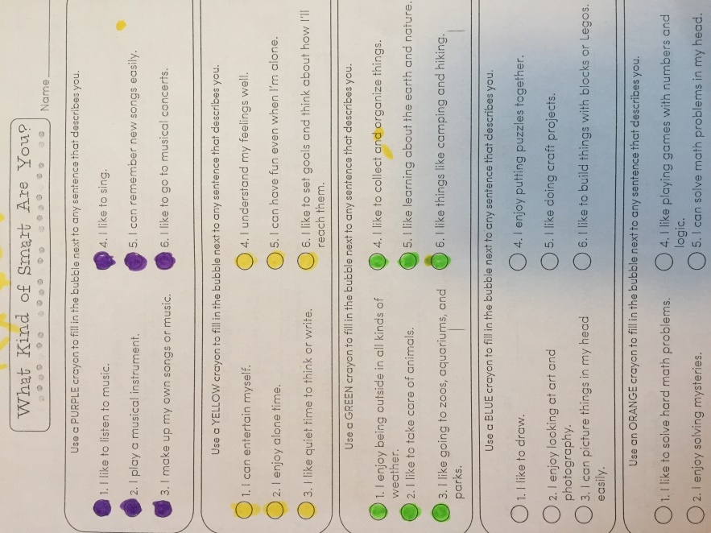
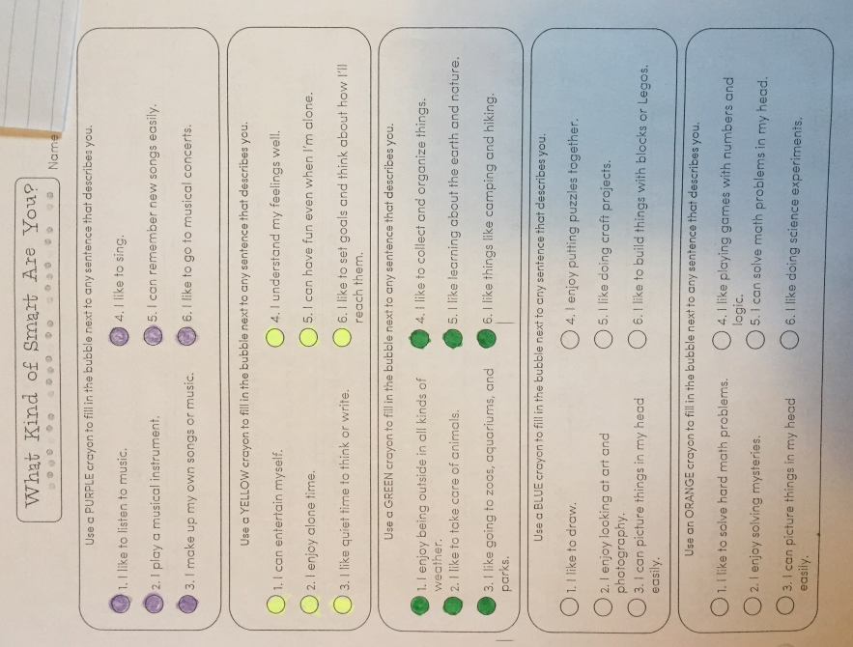

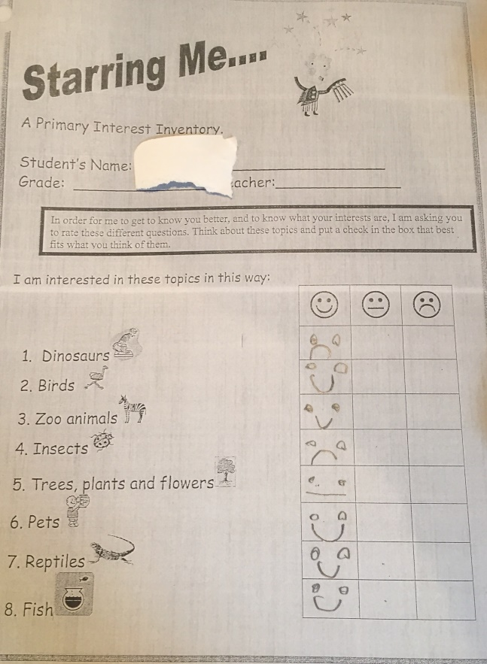
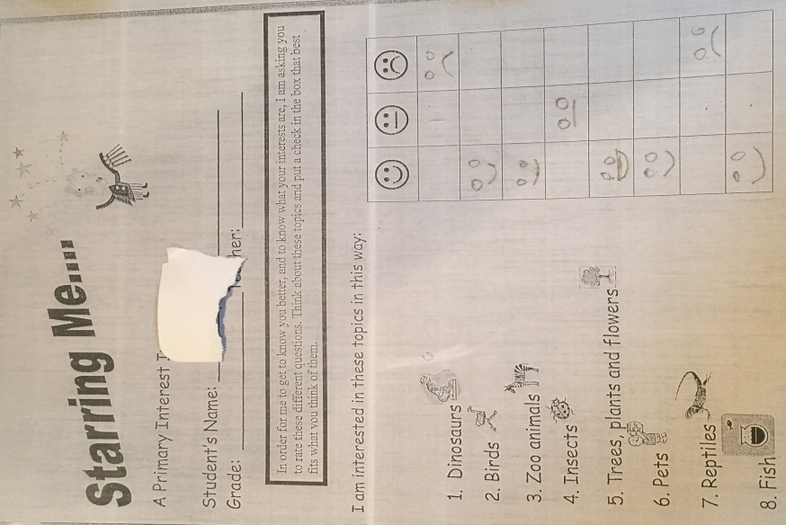
This sample shows that the modified survey was easier for students to understand and follow, as these two students worked individually and at their own pace to complete their whole booklet.

